LAPORAN KUIS

Nama : Georgina V S

Kelas : CE-5C

NIM : 1805114014

Source Code: https://drive.google.com/drive/folders/10xdPxOR9cNcU7bKrETVTGlAhgDvvXNZU?usp=sharing

1.Tampilan Web:

a.Home

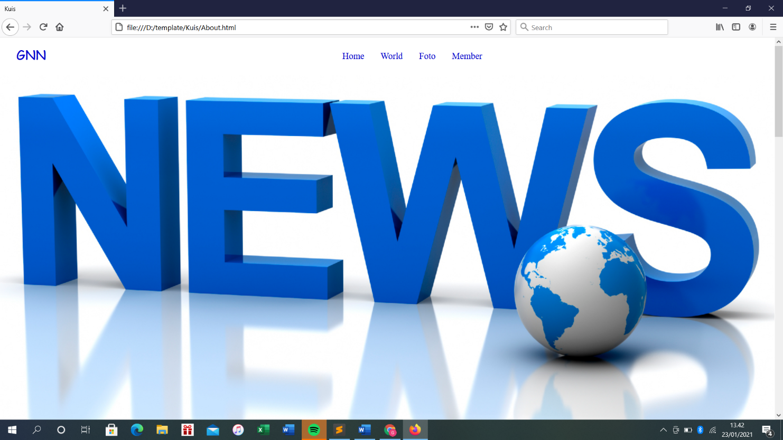

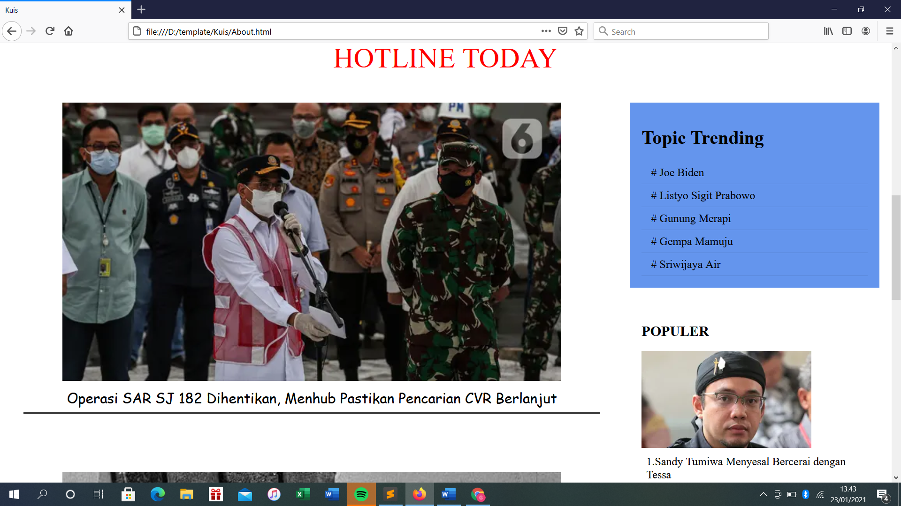

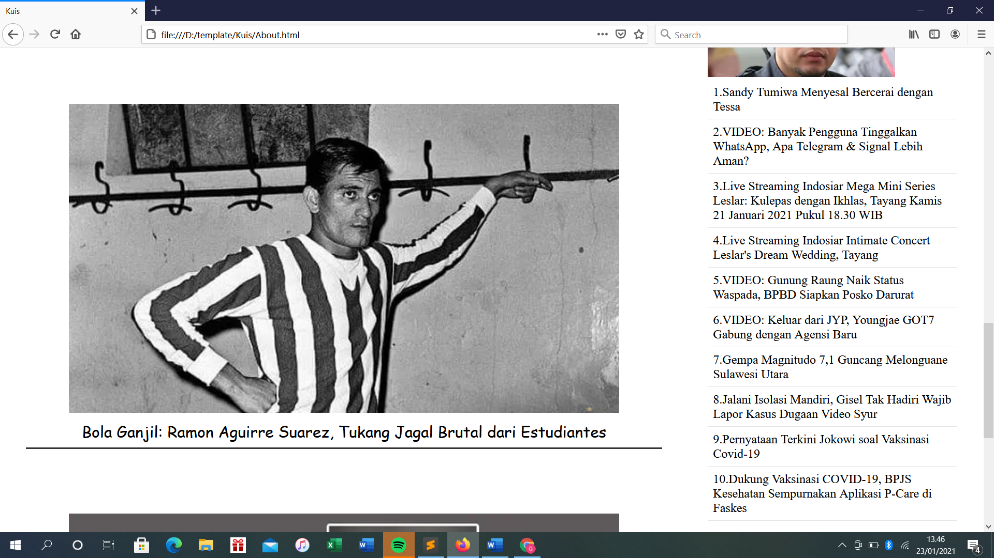

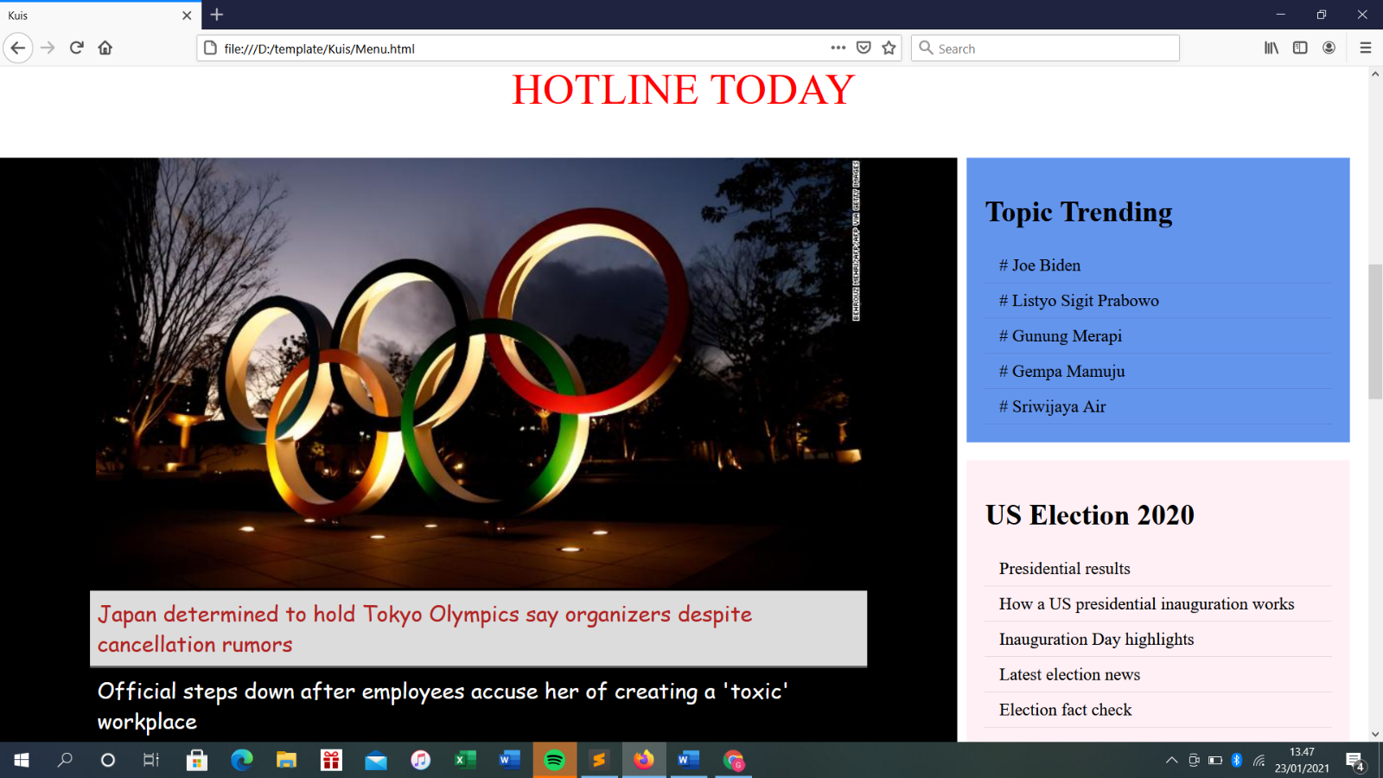b. World

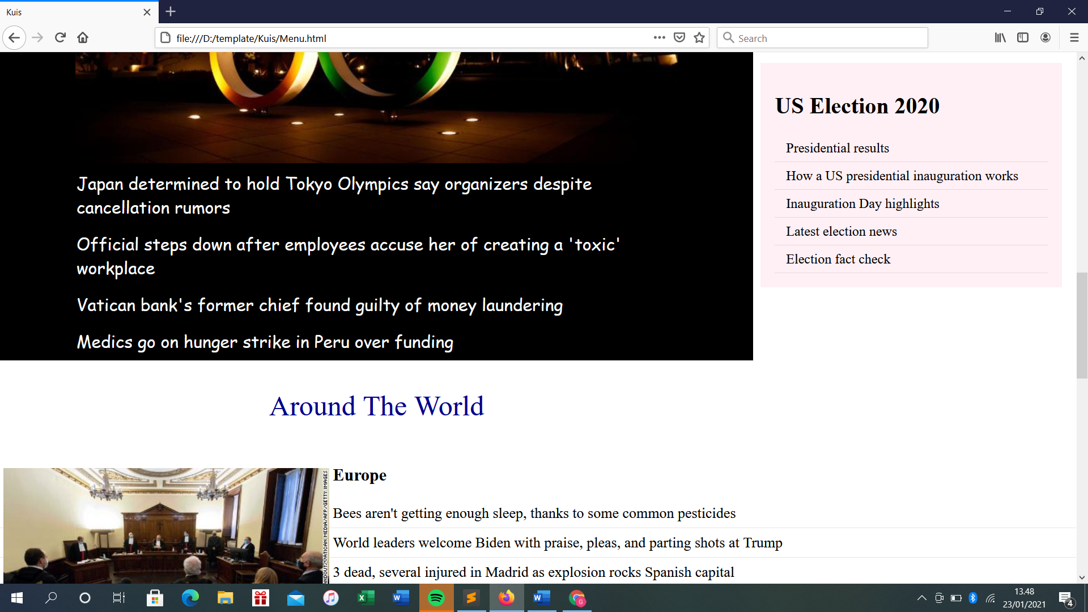

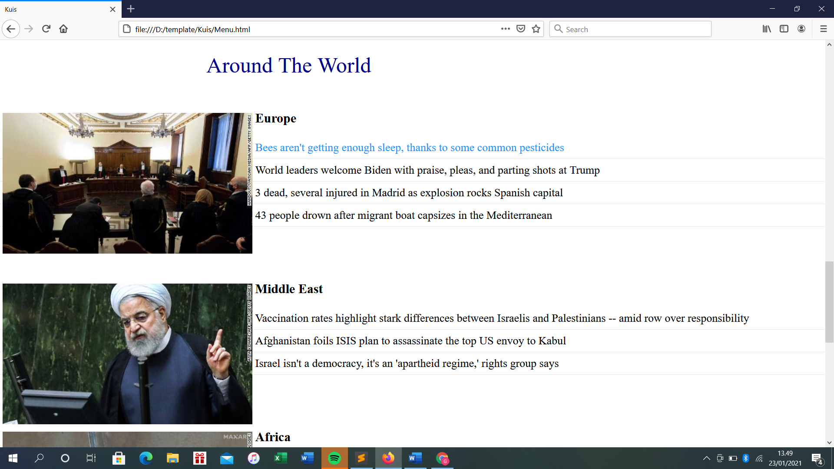

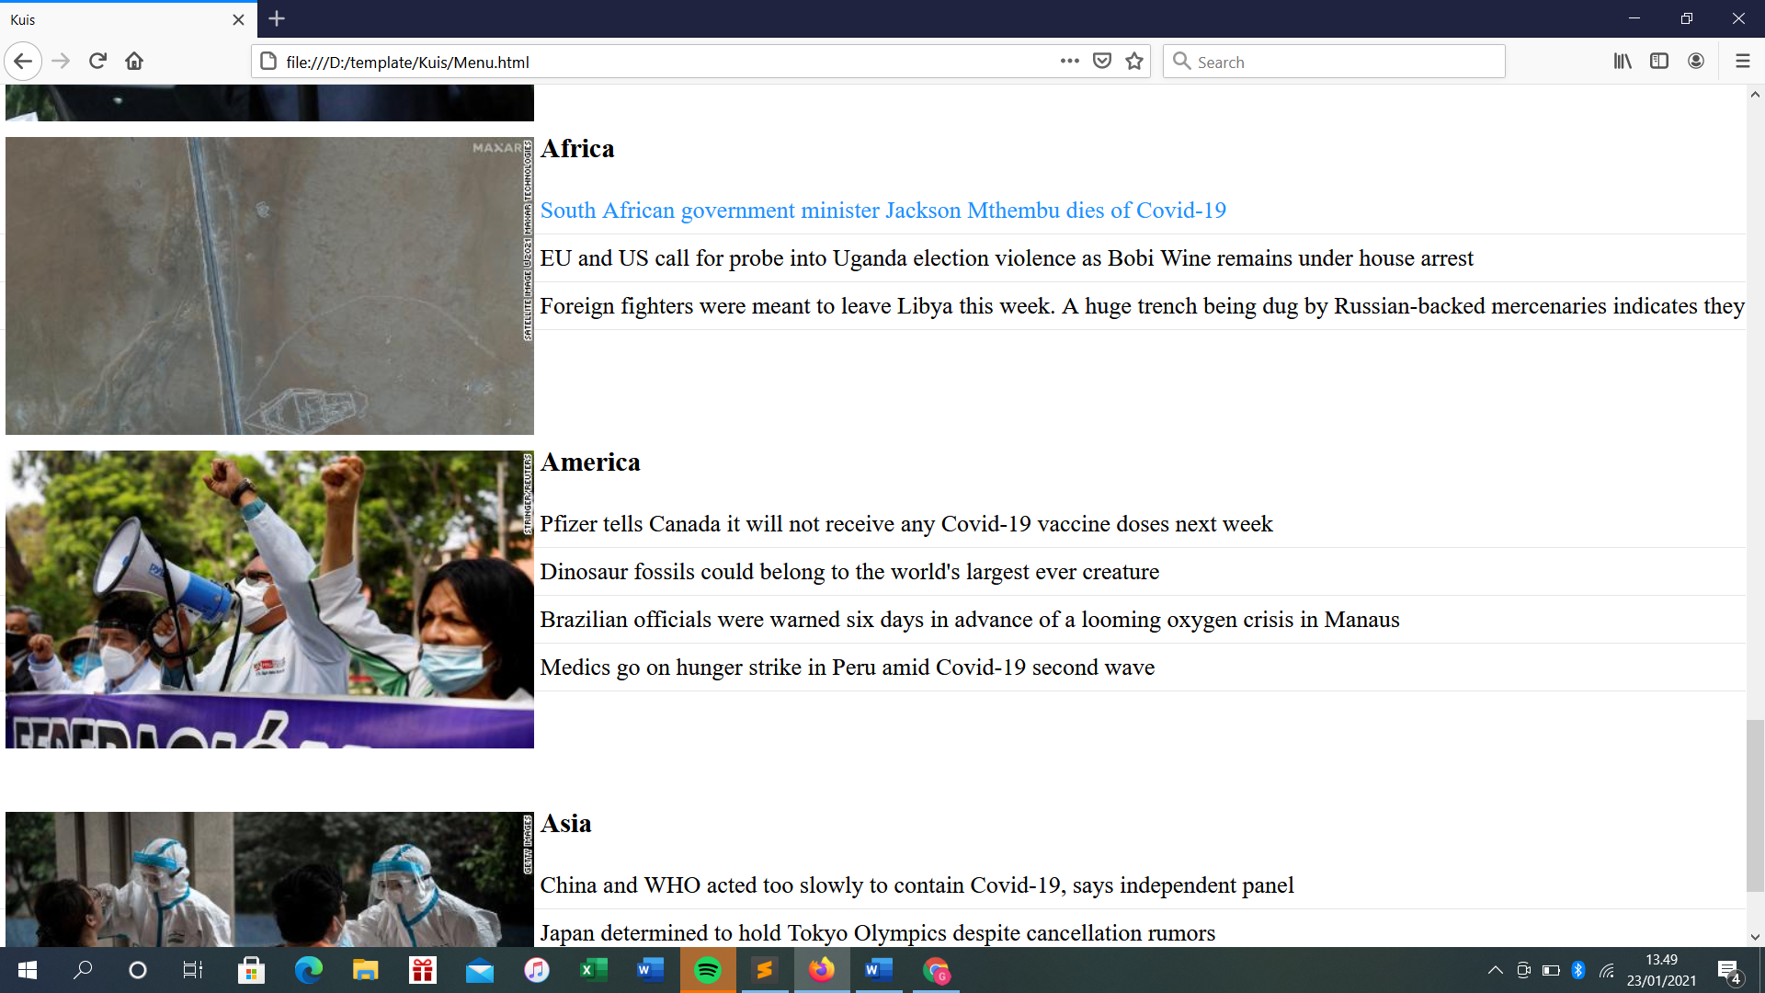

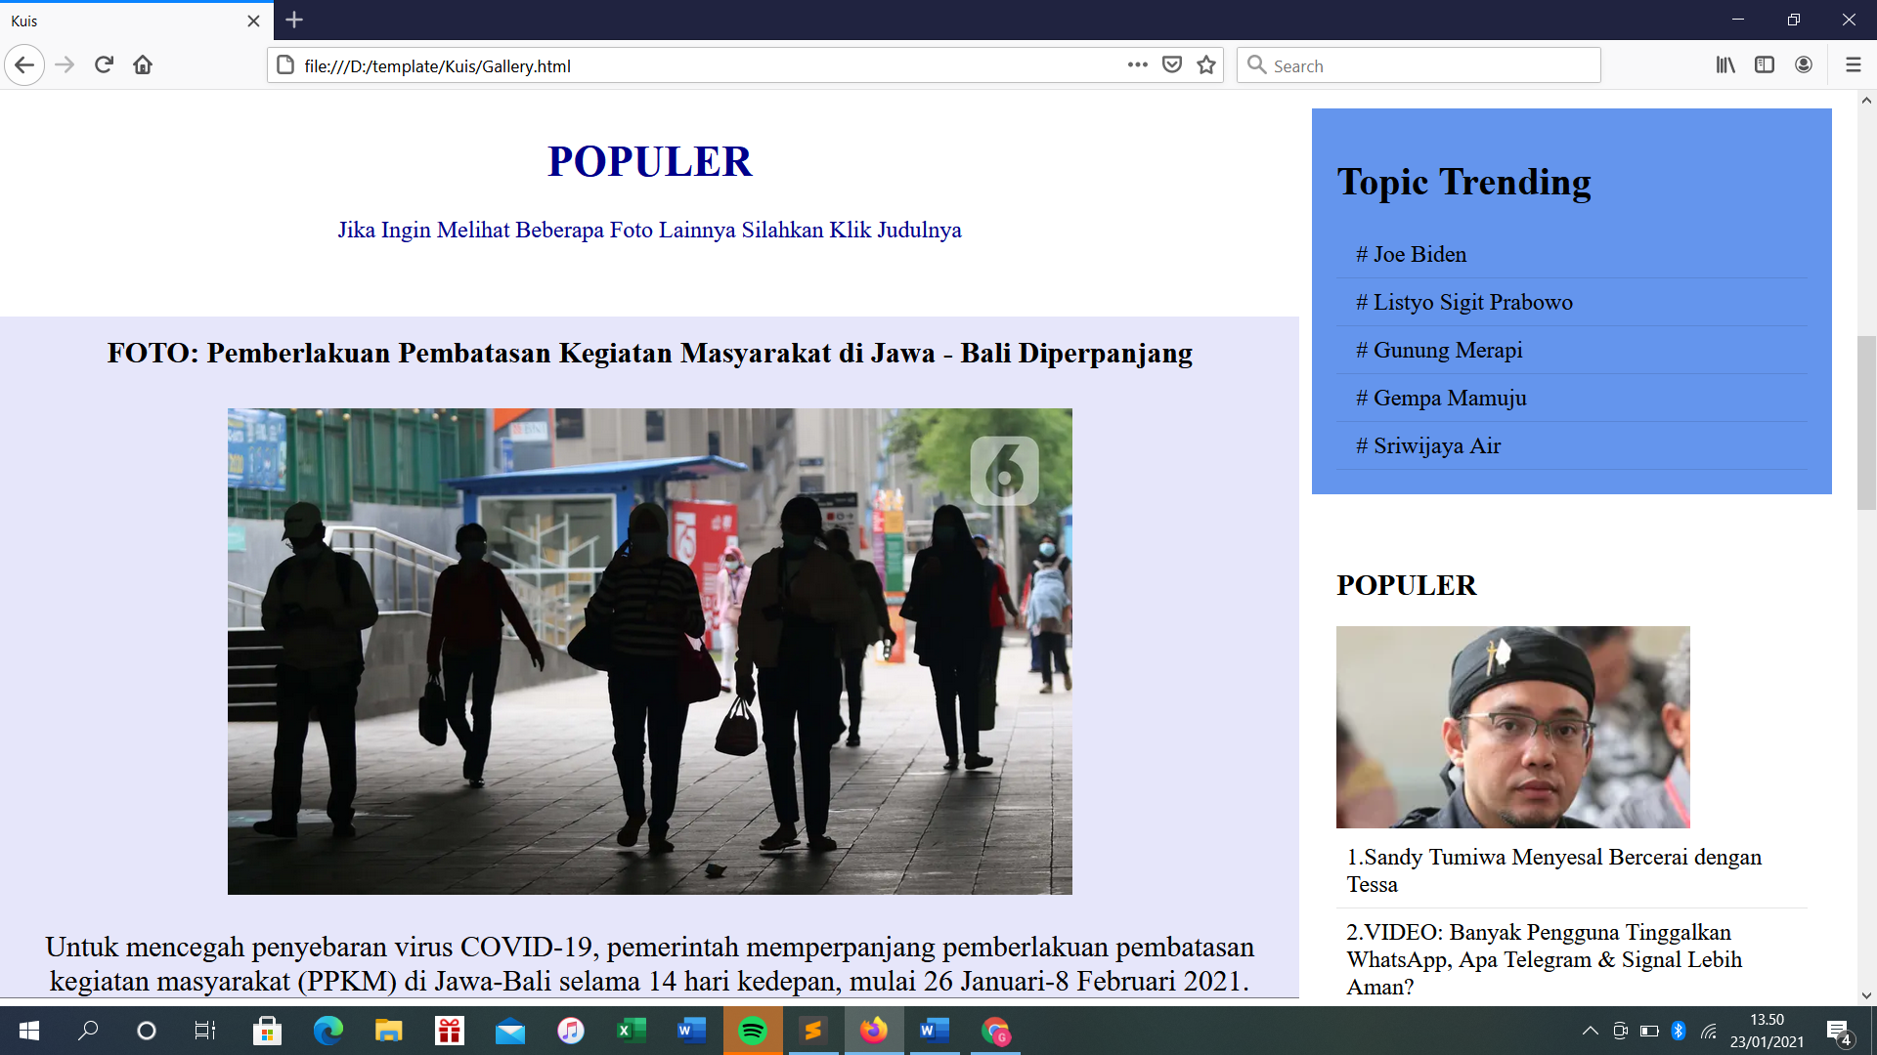c. Foto

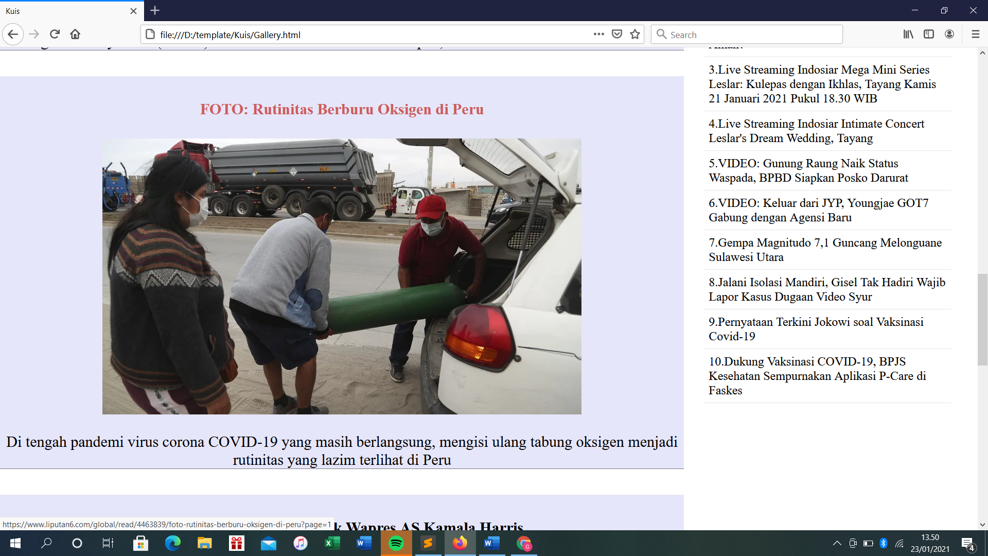

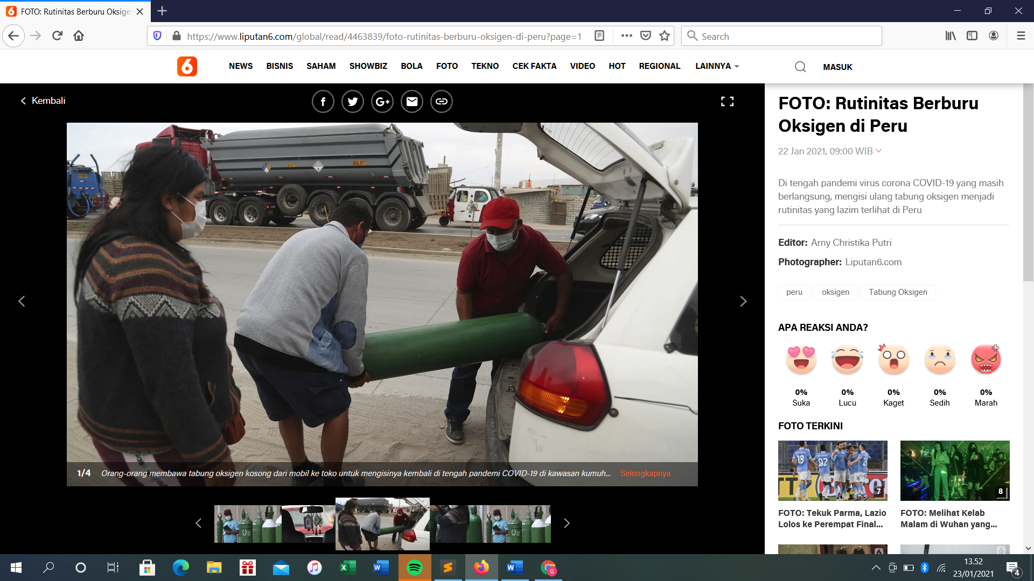Jika judulnya di klik maka akan langsung menuju ke website sumbernya

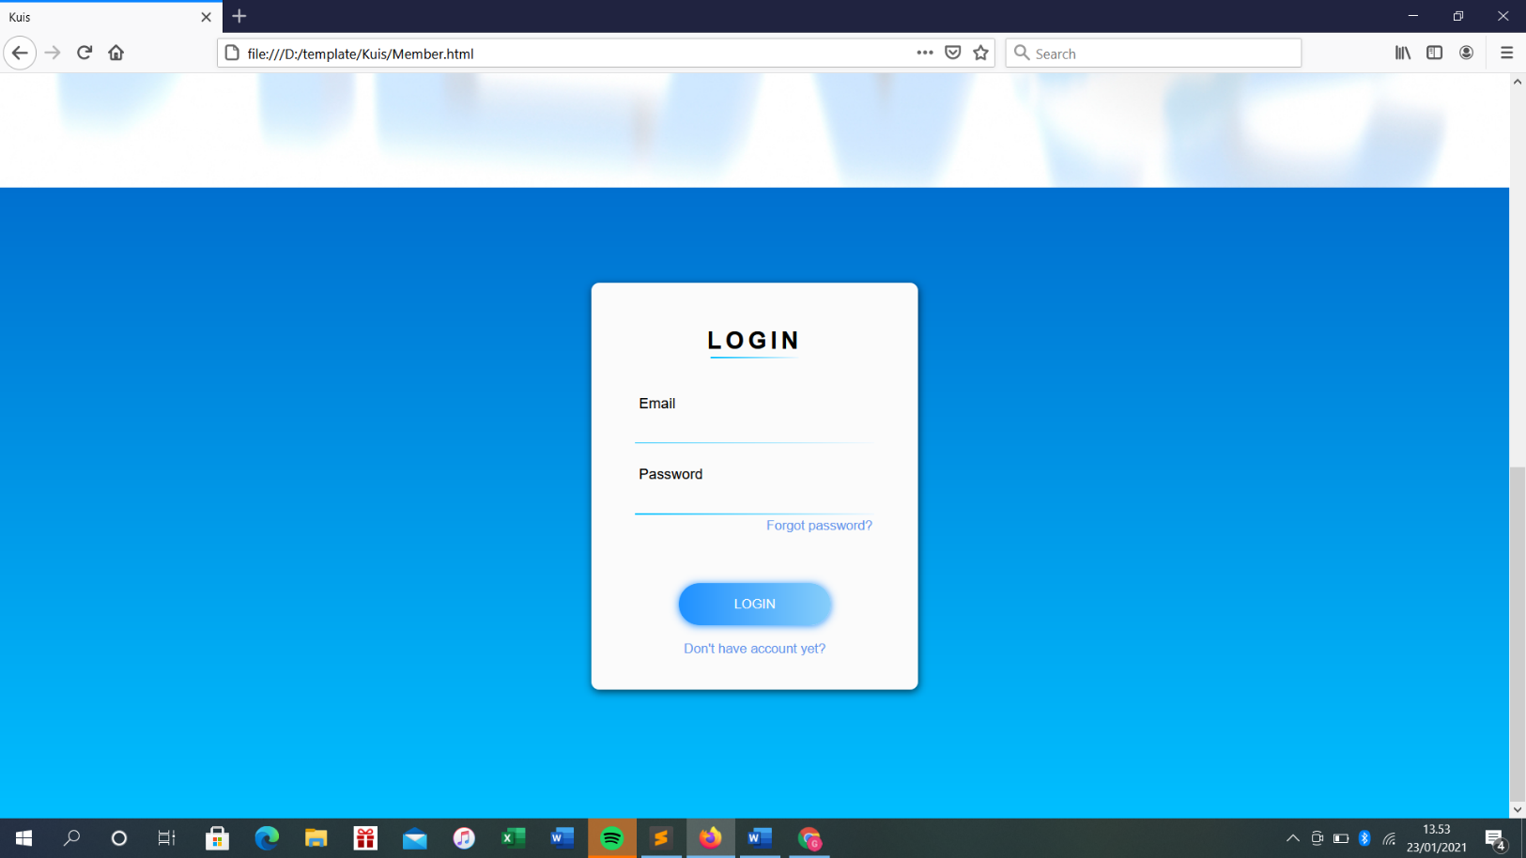d. Login

2. Responsive Web

a.Home

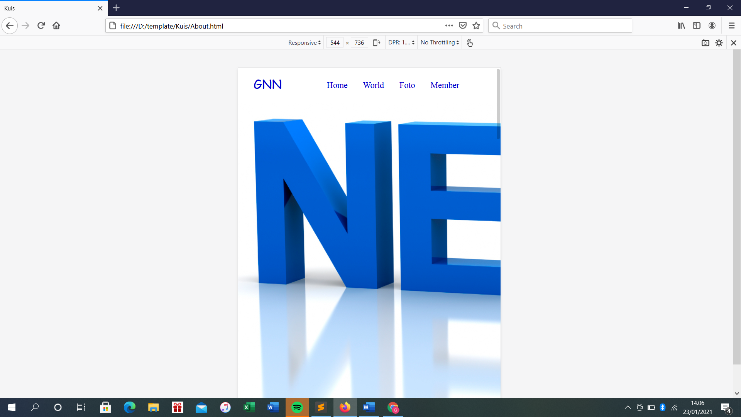

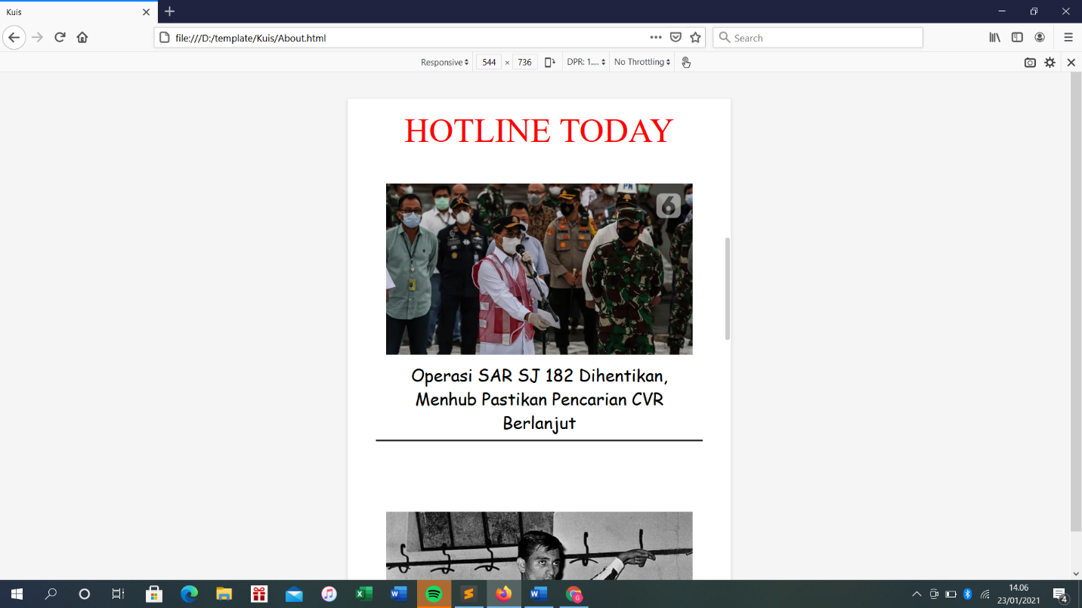

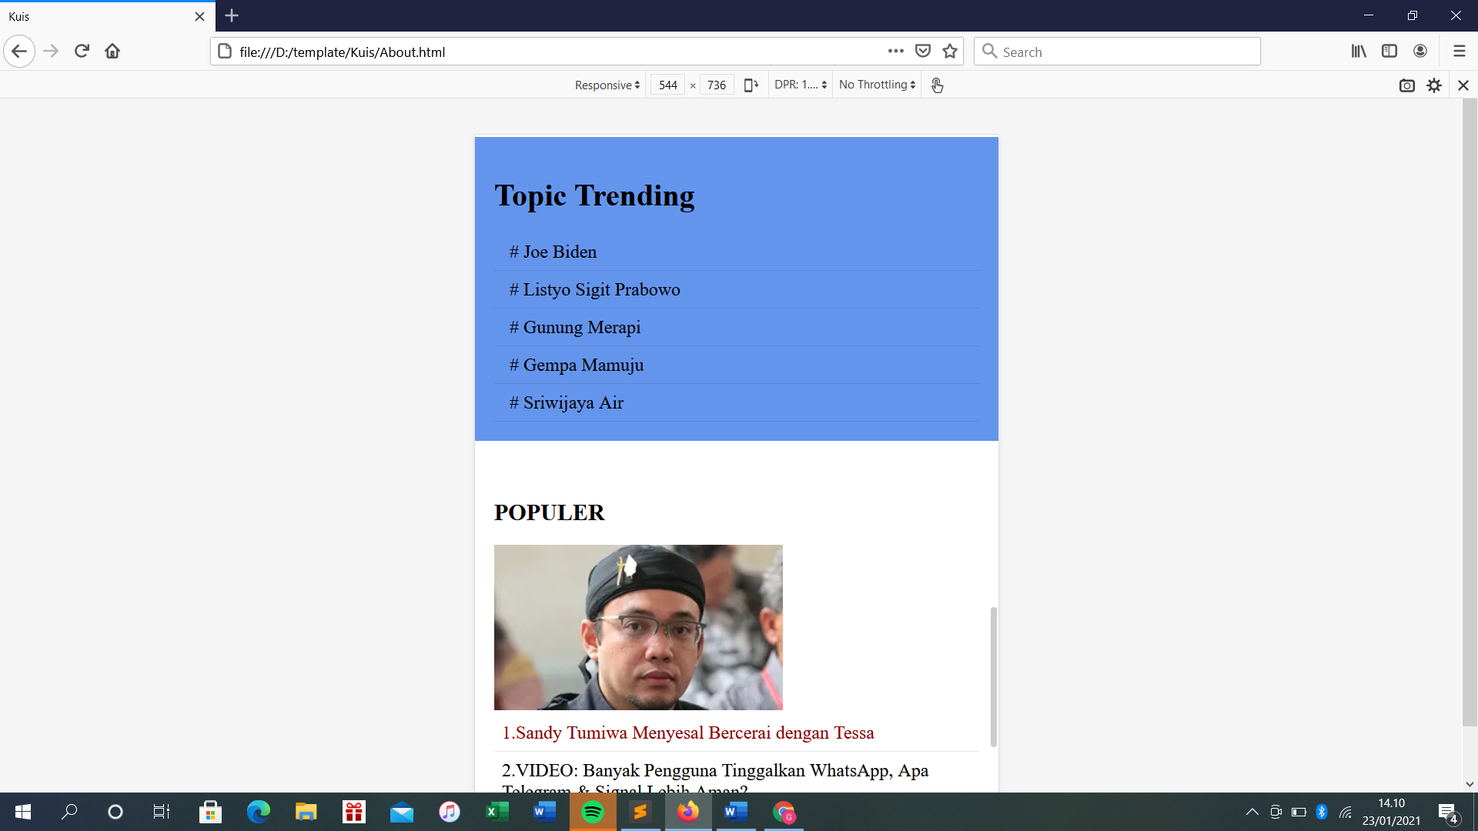

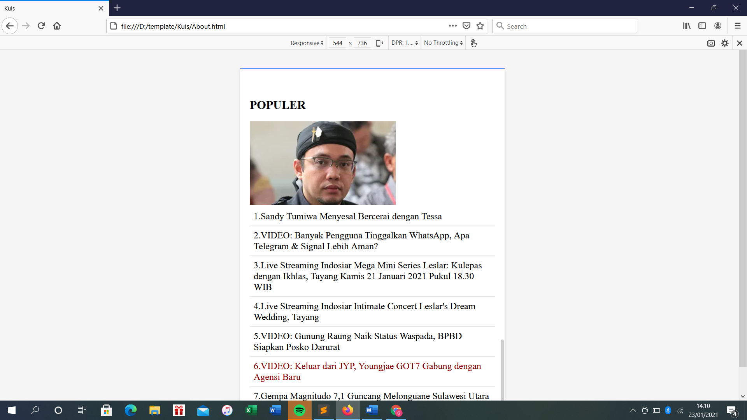

b. World

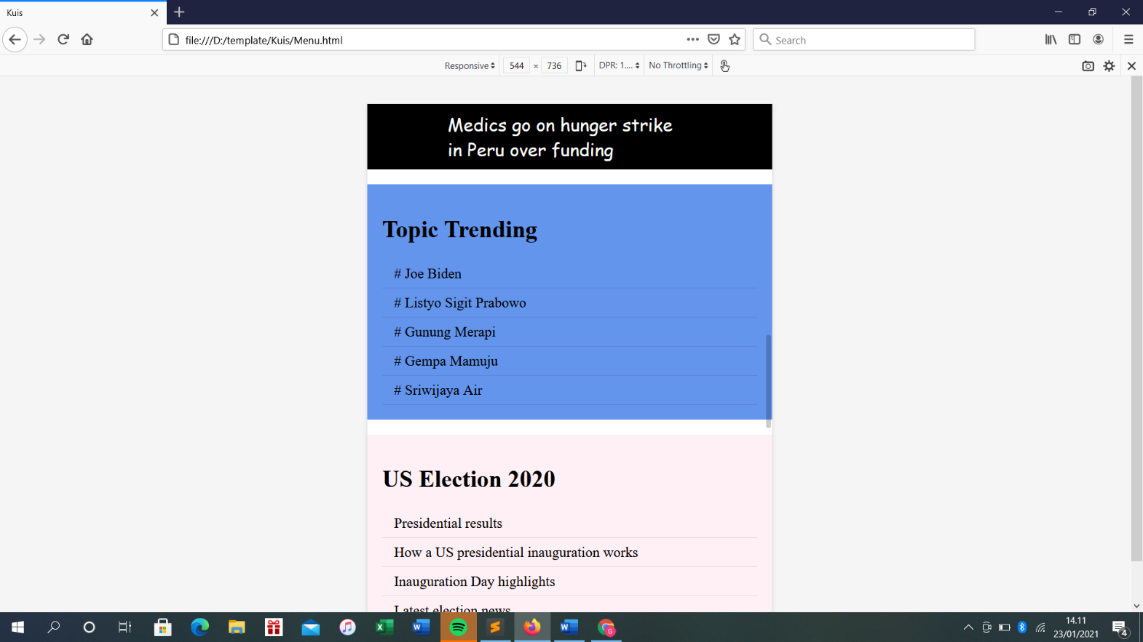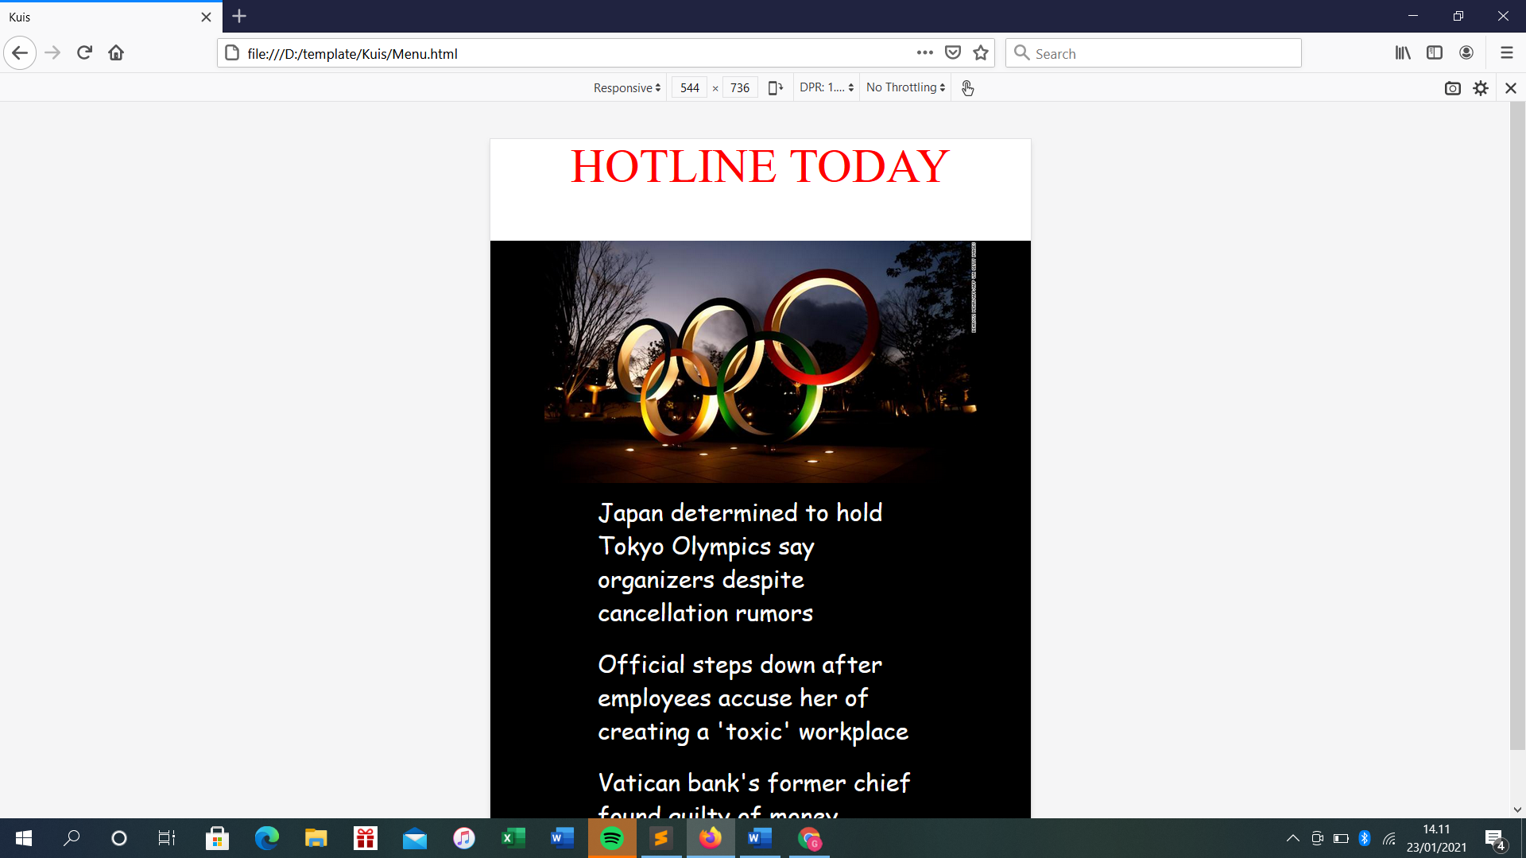

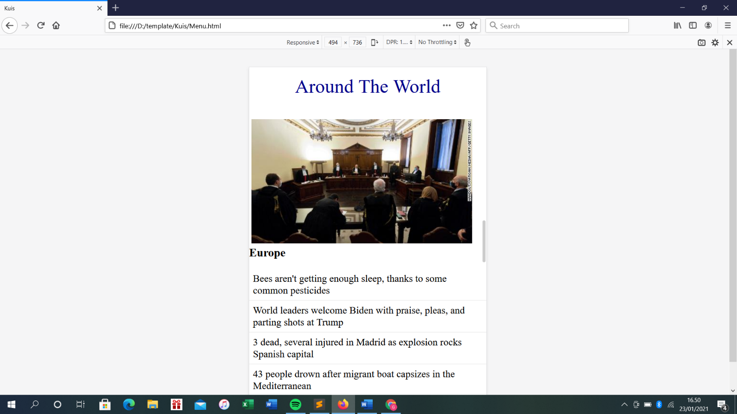

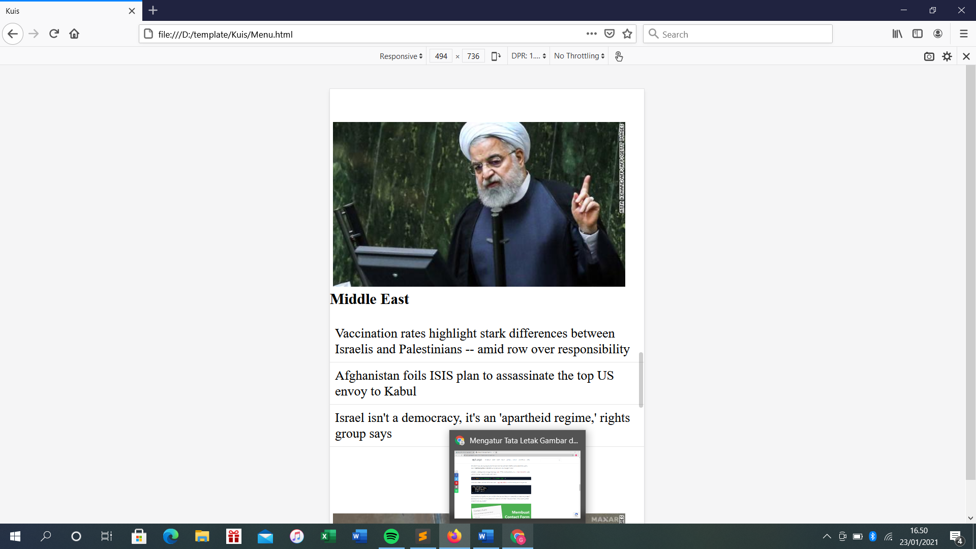

c. Foto

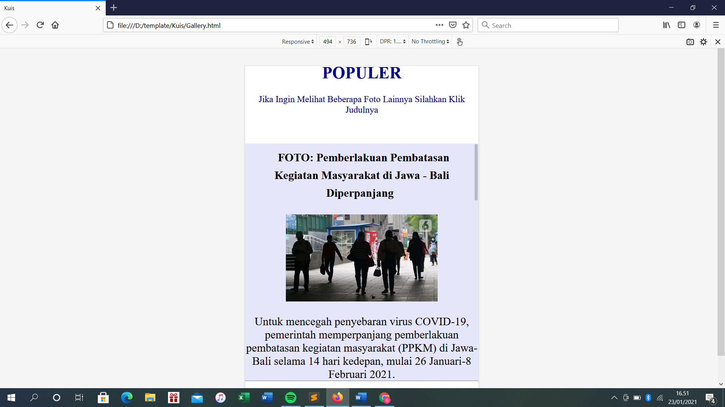

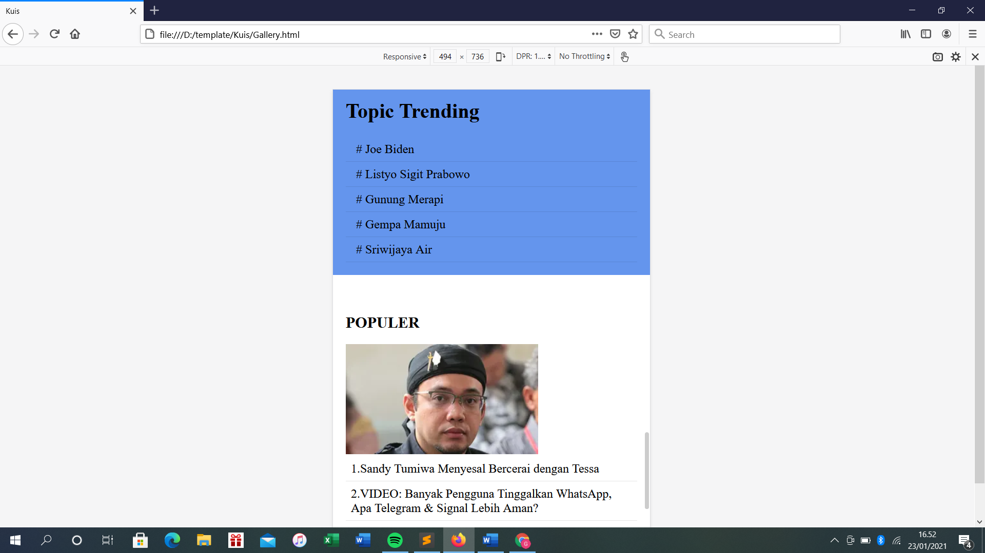

d. login

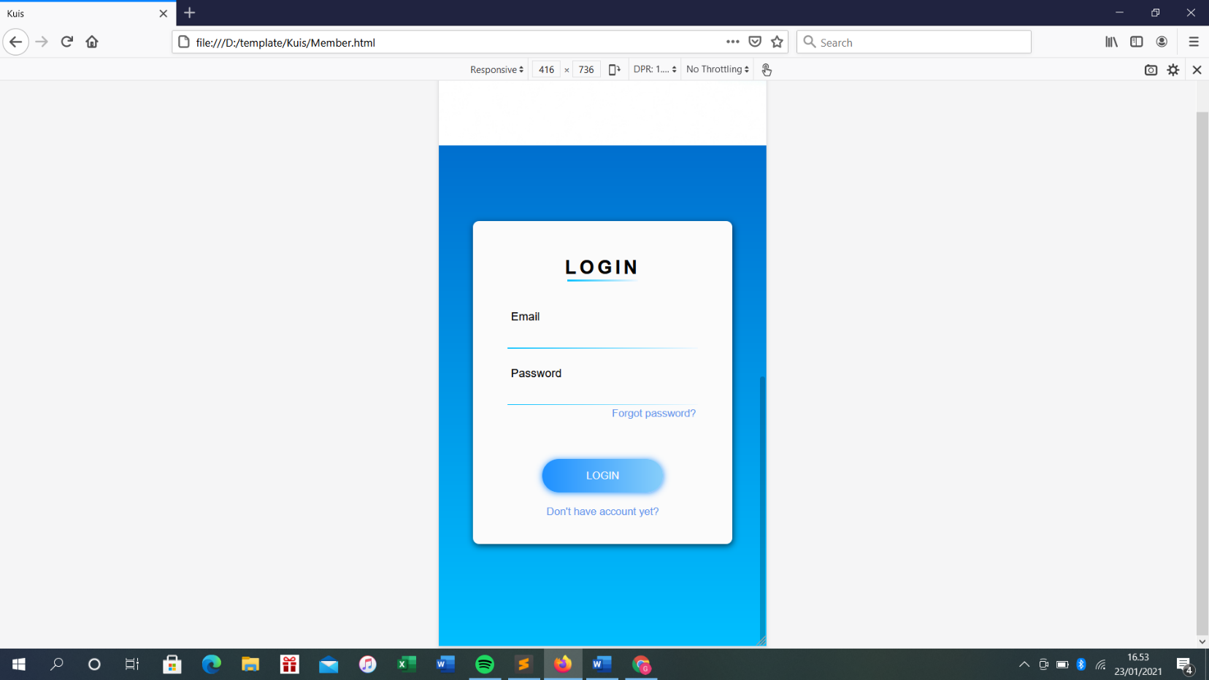

3. Koding

a) Home

**- HTML:**

<!DOCTYPE html>

<html>

<head>

<title>Kuis</title>

<link rel="stylesheet" type="text/css" href="about.css">

</head>

<body>

<nav class="nav">

<div class="nav-menu flex-row">

<div class="nav-brand">

<a href="#" class="text-gray">GNN</a>

</div>

<div class="toggle-collapse">

<div class="toggle-icons">

<i class="fas fa-bars"></i>

</div>

</div>

<div class="navi">

<ul class="nav-items">

<li class="nav-link">

<a href="About.html">Home</a>

</li>

<li class="nav-link">

<a href="Menu.html">World</a>

</li>

<li class="nav-link">

<a href="Gallery.html">Foto</a>

</li>

<li class="nav-link">

<a href="Member.html">Member</a>

</li>

</ul>

</div>

<div class="social text-gray">

<a href="#"></a>

</div>

</div>

</nav>

<section class="site-title">

<div class="site-background" data-aos="fade-up" data-aos-delay="100">

</div>

</section>

<div class="full-width margin-top20px">

<div class="post-title">

<center> <p> HOTLINE TODAY </p> </center>

<div class="col-7">

<div class="post-1">

<center> <img src="https://cdn1-production-images-kly.akamaized.net/fvj9Te8ViCTl0LItdmOYth_ak-c=/640x358/smart/filters:quality(75):strip_icc():format(webp)/kly-media-production/medias/3347289/original/029208600_1610455182-20210112-Bersama-Panglima-TNI_-Menhub-Budi-Karya-Sampaikan-Perkembangan-Terakhir-Pencarian-Korban-Sriwijaya-Air-SJ-182-1.jpg"></center>

<center><ul>

<li>Operasi SAR SJ 182 Dihentikan, Menhub Pastikan Pencarian CVR Berlanjut</li>

</ul></center>

</div>

<div class="post-2">

<center> <img src="https://cdn0-production-images-kly.akamaized.net/9ya86OYBdi6WOSxtCTs6FbM8DMQ=/0x0:1200x676/640x360/filters:quality(75):strip_icc():format(webp)/kly-media-production/medias/3353668/original/036215900_1611068240-EkpPdH3WkAAl9W0.jpg"></center>

<center><ul>

<li>Bola Ganjil: Ramon Aguirre Suarez, Tukang Jagal Brutal dari Estudiantes</li>

</ul></center>

</div>

<div class="post-3">

<center> <img src="https://cdn1-production-images-kly.akamaized.net/bddLXuyPc1XsfAkk8JR6k_5uRVE=/640x360/smart/filters:quality(75):strip_icc():format(webp)/kly-media-production/medias/3354790/original/092916500_1611154716-gunung.jpg"></center>

<center><ul>

<li>Infografis Erupsi Gunung Merapi, Semeru, Sinabung</li>

</ul></center>

</div>

</div>

<div class="col-3">

<h1>Topic Trending</h1>

<ul>

<li>

<a href=#> # Joe Biden </a>

</li>

<li>

<a href=#> # Listyo Sigit Prabowo </a>

</li>

<li>

<a href=#> # Gunung Merapi </a>

</li>

<li>

<a href=#> # Gempa Mamuju </a>

</li>

<li>

<a href=#> # Sriwijaya Air </a>

</li>

</ul>

</div>

<div class="col-4">

<h2> POPULER </h2>

<img src="https://cdn0-production-images-kly.akamaized.net/0muxIuuJ7rOH1bBb5--5C6zjujg=/300x172/smart/filters:quality(75):strip_icc():format(webp)/kly-media-production/medias/2004092/original/022259000_1521263284-20180301121707_IMG_8709-01.jpeg">

<ul>

<li> 1.Sandy Tumiwa Menyesal Bercerai dengan Tessa </li>

<li> 2.VIDEO: Banyak Pengguna Tinggalkan WhatsApp, Apa Telegram & Signal Lebih Aman? </li>

<li> 3.Live Streaming Indosiar Mega Mini Series Leslar: Kulepas dengan Ikhlas, Tayang Kamis 21 Januari 2021 Pukul 18.30 WIB </li>

<li> 4.Live Streaming Indosiar Intimate Concert Leslar's Dream Wedding, Tayang </li>

<li> 5.VIDEO: Gunung Raung Naik Status Waspada, BPBD Siapkan Posko Darurat </li>

<li> 6.VIDEO: Keluar dari JYP, Youngjae GOT7 Gabung dengan Agensi Baru </li>

<li> 7.Gempa Magnitudo 7,1 Guncang Melonguane Sulawesi Utara </li>

<li> 8.Jalani Isolasi Mandiri, Gisel Tak Hadiri Wajib Lapor Kasus Dugaan Video Syur </li>

<li> 9.Pernyataan Terkini Jokowi soal Vaksinasi Covid-19 </li>

<li> 10.Dukung Vaksinasi COVID-19, BPJS Kesehatan Sempurnakan Aplikasi P-Care di Faskes </li>

</ul>

</div>

</div>

</div>

</body>

</html>

**- CSS:**

html, body{

margin: 0%;

box-sizing: border-box;

overflow-x: hidden;

}

:root{

/* Theme colors */

--text-gray: #0000CD;

--text-light : #686666da;

--bg-color: #0f0f0f;

--midnight: #104f55;

/* gradient color */

/* theme font-family */

--Lexend: 'Lexend', cursive;

--Livvic : 'Livvic', cursive;

}

/* ---------------- Global Classes ---------------*/

a{

text-decoration: none;

color: var(--text-gray);

}

.flex-row{

display: flex;

flex-direction: row;

flex-wrap: wrap;

}

ul{

list-style-type: none;

}

button.btn{

border: none;

border-radius: 2rem;

padding: 1rem 3rem;

font-size: 1rem;

font-family: var(--Livvic);

cursor: pointer;

}

span{

font-family: var(--Abel);

}

.container{

margin: 0 5vw;

}

.text-gray{

color: var(--text-gray);

}

p{

font-family: var(--Lexend);

color: var(--text-light);

}

/* ------x------- Global Classes -------x-------*/

/* --------------- navbar ----------------- */

.nav{

background: white;

padding: 0 2rem;

height: 0rem;

min-height: 10vh;

overflow: hidden;

transition: height 1s ease-in-out;

}

.nav .nav-menu{

justify-content: space-between;

}

.nav .toggle-collapse{

position: absolute;

top: 0%;

width: 90%;

cursor: pointer;

display: none;

}

.nav .toggle-collapse .toggle-icons{

display: flex;

justify-content: flex-end;

padding: 1.7rem 0;

}

.nav .toggle-collapse .toggle-icons i{

font-size: 1.4rem;

color: var(--text-gray);

}

.collapse{

height: 30rem;

}

.nav .nav-items{

display: flex;

margin: 0;

}

.nav .nav-items .nav-link{

padding: 1.6rem 1rem;

font-size: 1.1rem;

position: relative;

font-family: var(--Abel);

font-size: 1.1rem;

}

.nav .nav-items .nav-link:hover{

background-color: #191970;

}

.nav .nav-items .nav-link:hover a{

color: #F0FFFF;

}

.nav .nav-brand a{

font-size: 1.6rem;

padding: 1rem 0;

display: block;

font-family: var(--Lexend);

font-size: 1.6rem;

}

.nav .social{

padding: 1.4rem 0

}

.nav .social i{

padding: 0 .2rem;

}

.nav .social i:hover{

color: #a1c4cf;

}

/* -------x------- navbar ---------x------- */

/* ----------------- Main Content----------- */

/* --------------- Site title ---------------- */

.site-title{

background: url('https://www.lendacademy.com/wp-content/uploads/2015/05/Marketplace-Lending-News.jpg');

background-size: cover;

height: 110vh;

display: flex;

justify-content: center;

}

.site-title .site-background{

padding-top: 10rem;

text-align: center;

color: var(--white);

}

.margin-top20px

{

margin-top: 20px;

}

.post-title p{

font-size: 3rem;

color: red;

font-family: var(--Abel);

}

.col-7 img{

width: 80%;

}

.post-1 ul

{

margin: 0;

padding: 0;

}

.post-1 ul li

{

list-style: none;

padding: 8px;

font-family: var(--Lexend);

font-size: 1.5rem;

color: black;

}

.post-1 ul li{

border-bottom: 3px solid rgba(0,0,0,0.8);

margin-left: 40px;

margin-right: 40px;

color: black;

}

.post-1 ul li:hover

{

color: #B22222;

}

.post-2{

margin-top: 100px;

}

.post-2 ul

{

margin: 0;

padding: 0;

}

.post-2 ul li

{

list-style: none;

padding: 8px;

font-family: var(--Lexend);

font-size: 1.5rem;

color: black;

}

.post-2 ul li{

border-bottom: 3px solid rgba(0,0,0,0.8);

margin-left: 40px;

margin-right: 40px;

color: black;

}

.post-2 ul li:hover

{

color: #B22222;

}

.post-3{

margin-top: 100px;

}

.post-3 ul

{

margin: 0;

padding: 0;

}

.post-3 ul li

{

list-style: none;

padding: 8px;

font-family: var(--Lexend);

font-size: 1.5rem;

color: black;

}

.post-3 ul li{

border-bottom: 3px solid rgba(0,0,0,0.8);

margin-left: 40px;

margin-right: 40px;

color: black;

}

.post-3 ul li:hover

{

color: #B22222;

}

.col-7

{

width: 70%;

min-height: 400px;

float: left;

}

.col-3

{

width: 28%;

min-height: 150px;

background:#6495ED;

float: right;

box-sizing: border-box;

padding: 20px;

margin-right: 20px;

}

.col-3 ul

{

margin: 0;

padding: 0;

}

.col-3 ul li

{

list-style: none;

padding: 8px;

border-bottom: 1px solid rgba(0,0,0,.1);

}

.col-3 a

{

list-style: none;

padding: 8px;

font-family: New Century Schoolbook;

font-size: 1.2rem;

color: black;

}

.col-3 a:hover

{

color: #fff;

}

.col-4

{

width: 28%;

min-height: 150px;

float: right;

box-sizing: border-box;

padding: 20px;

margin-right: 20px;

margin-top: 20px;

}

.col-4 ul

{

margin: 0;

padding: 0;

}

.col-4 ul li

{

list-style: none;

padding: 8px;

font-family: New Century Schoolbook;

font-size: 1.2rem;

color: black;

}

.col-4 ul li

{

list-style: none;

padding: 8px;

border-bottom: 1px solid rgba(0,0,0,.1);

}

.col-4 ul li:hover

{

color: #8B0000;

}

.col-4 img

{

max-width: 75%;

}

@media (max-width: 900px)

{

.navi ul li

{

display: block;

text-align: center;

}

.col-7,

.col-3,

.col-4

{

width: 100%;

float: none;

}

.col-3,

.col-4

{

margin-top: 20px;

}

}

b. World

- **HTML**:

<!DOCTYPE html>

<html>

<head>

<title>Kuis</title>

<link rel="stylesheet" type="text/css" href="menu.css">

</head>

<body>

<nav class="nav">

<div class="nav-menu flex-row">

<div class="nav-brand">

<a href="#" class="text-gray">GNN</a>

</div>

<div class="toggle-collapse">

<div class="toggle-icons">

<i class="fas fa-bars"></i>

</div>

</div>

<div>

<ul class="nav-items">

<li class="nav-link">

<a href="About.html">Home</a>

</li>

<li class="nav-link">

<a href="Menu.html">World</a>

</li>

<li class="nav-link">

<a href="Gallery.html">Foto</a>

</li>

<li class="nav-link">

<a href="Member.html">Member</a>

</li>

</ul>

</div>

<div class="social text-gray">

<a href="#"></a>

</div>

</div>

</nav>

<section class="site-title">

<div class="site-background" data-aos="fade-up" data-aos-delay="100">

</div>

</section>

<div class="full-width margin-top20px">

<div class="post-title">

<center> <p> HOTLINE TODAY </p> </center>

<div class="col-7">

<div class="post-1">

<center><img src="https://cdn.cnn.com/cnnnext/dam/assets/210113215424-tokyo-2020-olympic-games-exlarge-169.jpg"></center>

<ul>

<li>Japan determined to hold Tokyo Olympics say organizers despite cancellation rumors</li>

<li>Official steps down after employees accuse her of creating a 'toxic' workplace</li>

<li>Vatican bank's former chief found guilty of money laundering</li>

<li>Medics go on hunger strike in Peru over funding</li>

</ul>

</div>

</div>

<div class="col-3">

<h1>Topic Trending</h1>

<ul>

<li>

<a href=#> # Joe Biden </a>

</li>

<li>

<a href=#> # Listyo Sigit Prabowo </a>

</li>

<li>

<a href=#> # Gunung Merapi </a>

</li>

<li>

<a href=#> # Gempa Mamuju </a>

</li>

<li>

<a href=#> # Sriwijaya Air </a>

</li>

</ul>

</div>

<div class="col-2">

<h1>US Election 2020</h1>

<ul>

<li>

<a href=#> Presidential results </a>

</li>

<li>

<a href=#> How a US presidential inauguration works </a>

</li>

<li>

<a href=#> Inauguration Day highlights </a>

</li>

<li>

<a href=#> Latest election news </a>

</li>

<li>

<a href=#> Election fact check </a>

</li>

</ul>

</div>

<div class="col-4">

<div class="title">

<center><p> Around The World </p></center>

</div>

</div>

<div class="col-5">

<div class="lo1">

<img src="https://cdn.cnn.com/cnnnext/dam/assets/210121143034-02-vatican-bank-money-laundering-large-169.jpg">

<h2>Europe</h2>

<ul>

<li>Bees aren't getting enough sleep, thanks to some common pesticides</li>

<li>World leaders welcome Biden with praise, pleas, and parting shots at Trump</li>

<li>3 dead, several injured in Madrid as explosion rocks Spanish capital</li>

<li>43 people drown after migrant boat capsizes in the Mediterranean</li>

</ul>

</div>

<div class="lo2">

<img src="https://cdn.cnn.com/cnnnext/dam/assets/190915084116-irans-president-hassan-rouhani-large-169.jpg">

<h2>Middle East</h2>

<ul>

<li>Vaccination rates highlight stark differences between Israelis and Palestinians -- amid row over responsibility</li>

<li>Afghanistan foils ISIS plan to assassinate the top US envoy to Kabul</li>

<li>Israel isn't a democracy, it's an 'apartheid regime,' rights group says</li>

</ul>

</div>

<div class="lo3">

<img src="https://cdn.cnn.com/cnnnext/dam/assets/210121152912-05-libya-trench-watermark-large-169.jpg">

<h2>Africa</h2>

<ul>

<li>South African government minister Jackson Mthembu dies of Covid-19</li>

<li>EU and US call for probe into Uganda election violence as Bobi Wine remains under house arrest</li>

<li>Foreign fighters were meant to leave Libya this week. A huge trench being dug by Russian-backed mercenaries indicates they plan to stay</li>

</ul>

</div>

<div class="lo4">

<img src="https://cdn.cnn.com/cnnnext/dam/assets/210121143821-01-peru-health-workers-protest-0113-large-169.jpg">

<h2>America</h2>

<ul>

<li>Pfizer tells Canada it will not receive any Covid-19 vaccine doses next week</li>

<li>Dinosaur fossils could belong to the world's largest ever creature</li>

<li>Brazilian officials were warned six days in advance of a looming oxygen crisis in Manaus</li>

<li>Medics go on hunger strike in Peru amid Covid-19 second wave</li>

</ul>

</div>

<div class="lo5">

<img src="https://cdn.cnn.com/cnnnext/dam/assets/201125170042-13-china-covid-large-169.jpg">

<h2>Asia</h2>

<ul>

<li>China and WHO acted too slowly to contain Covid-19, says independent panel</li>

<li>Japan determined to hold Tokyo Olympics despite cancellation rumors</li>

<li>South Korean former Olympic skating coach jailed for 10 years over abuse</li>

<li>Blaze at facility of world's biggest vaccine maker kills 5 people</li>

</ul>

</div>

</div>

</div>

</div>

</body>

</html>

- **CSS** :

html, body{

margin: 0%;

box-sizing: border-box;

overflow-x: hidden;

}

:root{

/* Theme colors */

--text-gray: #0000CD;

--text-light : #686666da;

--bg-color: #0f0f0f;

--midnight: #104f55;

/* gradient color */

/* theme font-family */

--Lexend: 'Lexend', cursive;

--Livvic : 'Livvic', cursive;

}

/* ---------------- Global Classes ---------------*/

a{

text-decoration: none;

color: var(--text-gray);

}

.flex-row{

display: flex;

flex-direction: row;

flex-wrap: wrap;

}

ul{

list-style-type: none;

}

button.btn{

border: none;

border-radius: 2rem;

padding: 1rem 3rem;

font-size: 1rem;

font-family: var(--Livvic);

cursor: pointer;

}

span{

font-family: var(--Abel);

}

.container{

margin: 0 5vw;

}

.text-gray{

color: var(--text-gray);

}

p{

font-family: var(--Lexend);

color: var(--text-light);

}

/* ------x------- Global Classes -------x-------*/

/* --------------- navbar ----------------- */

.nav{

background: white;

padding: 0 2rem;

height: 0rem;

min-height: 10vh;

overflow: hidden;

transition: height 1s ease-in-out;

}

.nav .nav-menu{

justify-content: space-between;

}

.nav .toggle-collapse{

position: absolute;

top: 0%;

width: 90%;

cursor: pointer;

display: none;

}

.nav .toggle-collapse .toggle-icons{

display: flex;

justify-content: flex-end;

padding: 1.7rem 0;

}

.nav .toggle-collapse .toggle-icons i{

font-size: 1.4rem;

color: var(--text-gray);

}

.collapse{

height: 30rem;

}

.nav .nav-items{

display: flex;

margin: 0;

}

.nav .nav-items .nav-link{

padding: 1.6rem 1rem;

font-size: 1.1rem;

position: relative;

font-family: var(--Abel);

font-size: 1.1rem;

}

.nav .nav-items .nav-link:hover{

background-color: #191970;

}

.nav .nav-items .nav-link:hover a{

color: #F0FFFF;

}

.nav .nav-brand a{

font-size: 1.6rem;

padding: 1rem 0;

display: block;

font-family: var(--Lexend);

font-size: 1.6rem;

}

.nav .social{

padding: 1.4rem 0

}

.nav .social i{

padding: 0 .2rem;

}

/* -------x------- navbar ---------x------- */

/* ----------------- Main Content----------- */

/* --------------- Site title ---------------- */

.site-title{

background: url('https://www.lendacademy.com/wp-content/uploads/2015/05/Marketplace-Lending-News.jpg');

background-size: cover;

height: 110vh;

display: flex;

justify-content: center;

}

.site-title .site-background{

padding-top: 10rem;

text-align: center;

color: var(--white);

}

.margin-top20px

{

margin-top: 20px;

}

.post-title p{

font-size: 3rem;

color: red;

font-family: var(--Abel);

}

.col-7 img{

width: 80%;

}

.post-1 ul

{

margin: 0;

padding: 0;

}

.post-1 ul li

{

list-style: none;

padding: 8px;

font-family: var(--Lexend);

font-size: 1.5rem;

color: black;

}

.post-1 ul li{

border-bottom: 3px solid rgba(0,0,0,0.5);

margin-left: 100px;

margin-right: 100px;

color: white;

}

.post-1 ul li:hover

{

color: #B22222;

background : #DCDCDC;

}

.post-1{

background: black;

}

.col-7

{

width: 70%;

min-height: 400px;

float: left;

}

.col-3

{

width: 28%;

min-height: 150px;

background:#6495ED;

float: right;

box-sizing: border-box;

padding: 20px;

margin-right: 20px;

}

.col-3 ul

{

margin: 0;

padding: 0;

}

.col-3 ul li

{

list-style: none;

padding: 8px;

border-bottom: 1px solid rgba(0,0,0,.1);

}

.col-3 a

{

list-style: none;

padding: 8px;

font-family: New Century Schoolbook;

font-size: 1.2rem;

color: black;

}

.col-3 a:hover

{

color: #fff;

}

.col-2

{

width: 28%;

min-height: 150px;

background:#FFF0F5;

float: right;

box-sizing: border-box;

padding: 20px;

margin-right: 20px;

margin-top: 20px;

}

.col-2 ul

{

margin: 0;

padding: 0;

}

.col-2 ul li

{

list-style: none;

padding: 8px;

border-bottom: 1px solid rgba(0,0,0,.1);

}

.col-2 a

{

list-style: none;

padding: 8px;

font-family: New Century Schoolbook;

font-size: 1.2rem;

color: black;

}

.col-2 a:hover

{

color: #FF7F50;

}

.col-4

{

width: 70%;

min-height: 10px;

float: left;

}

.col-4 p

{

font-family: New Century Schoolbook;

font-size: 2.5rem;

color: #00008B;

}

.col-5

{

width: 800%;

min-height: 400px;

float: left;

}

.lo1 img{

float: left;

margin: 5px;

}

.lo1 ul

{

margin: 0;

padding: 0;

}

.lo1 ul li

{

list-style: none;

padding: 8px;

font-family: New Century Schoolbook;

font-size: 1.3rem;

color: black;

border-bottom: 1px solid rgba(0,0,0,.1);

}

.lo1 ul li:hover

{

color: #1E90FF;

}

.lo2{

margin-top: 100px;

}

.lo2 img{

float: left;

margin: 5px;

}

.lo2 ul

{

margin: 0;

padding: 0;

}

.lo2 ul li

{

list-style: none;

padding: 8px;

font-family: New Century Schoolbook;

font-size: 1.3rem;

color: black;

border-bottom: 1px solid rgba(0,0,0,.1);

}

.lo2 ul li:hover

{

color: #1E90FF;

}

.lo3{

margin-top: 100px;

}

.lo3 img{

float: left;

margin: 5px;

}

.lo3 ul

{

margin: 0;

padding: 0;

}

.lo3 ul li

{

list-style: none;

padding: 8px;

font-family: New Century Schoolbook;

font-size: 1.3rem;

color: black;

border-bottom: 1px solid rgba(0,0,0,.1);

}

.lo3 ul li:hover

{

color: #1E90FF;

}

.lo4{

margin-top: 100px;

}

.lo4 img{

float: left;

margin: 5px;

}

.lo4 ul

{

margin: 0;

padding: 0;

}

.lo4 ul li

{

list-style: none;

padding: 8px;

font-family: New Century Schoolbook;

font-size: 1.3rem;

color: black;

border-bottom: 1px solid rgba(0,0,0,.1);

}

.lo4 ul li:hover

{

color: #1E90FF;

}

.lo5{

margin-top: 100px;

}

.lo5 img{

float: left;

margin: 5px;

}

.lo5 ul

{

margin: 0;

padding: 0;

}

.lo5 ul li

{

list-style: none;

padding: 8px;

font-family: New Century Schoolbook;

font-size: 1.3rem;

color: black;

border-bottom: 1px solid rgba(0,0,0,.1);

}

.lo5 ul li:hover

{

color: #1E90FF;

}

@media (max-width: 900px)

{

.navi ul li

{

display: block;

text-align: center;

}

.col-7,

.col-3,

.col-4,

.col-2,

.col-5

{

width: 100%;

float: none;

}

.col-3,

.col-4,

.col-2,

.col-5

{

margin-top: 20px;

}

.col-5 {

max-width: 100%;

display:block;

height: auto;

}

}

C. Foto:

- **HTML :**

<!DOCTYPE html>

<html>

<head>

<title>Kuis</title>

<link rel="stylesheet" type="text/css" href="gallery.css">

</head>

<body>

<nav class="nav">

<div class="nav-menu flex-row">

<div class="nav-brand">

<a href="#" class="text-gray">GNN</a>

</div>

<div class="toggle-collapse">

<div class="toggle-icons">

<i class="fas fa-bars"></i>

</div>

</div>

<div>

<ul class="nav-items">

<li class="nav-link">

<a href="About.html">Home</a>

</li>

<li class="nav-link">

<a href="Menu.html">World</a>

</li>

<li class="nav-link">

<a href="Gallery.html">Foto</a>

</li>

<li class="nav-link">

<a href="Member.html">Member</a>

</li>

</ul>

</div>

<div class="social text-gray">

<a href="#"></a>

</div>

</div>

</nav>

<section class="site-title">

<div class="site-background" data-aos="fade-up" data-aos-delay="100">

</div>

</section>

<div class="col-1">

<div class="post">

<center><h1> POPULER </h1></center>

<center><p>Jika Ingin Melihat Beberapa Foto Lainnya Silahkan Klik Judulnya</p></center>

</div>

<div class="lo1">

<center> <ul><h1><li><a href="https://www.liputan6.com/news/read/4463675/foto-pemberlakuan-pembatasan-kegiatan-masyarakat-di-jawa-bali-diperpanjang?page=1">FOTO: Pemberlakuan Pembatasan Kegiatan Masyarakat di Jawa - Bali Diperpanjang</a></li></h1></ul></center>

<center> <img src="https://cdn1-production-images-kly.akamaized.net/i8deTTk06E8CmLP0fqmZUu_hbKM=/1231x710/smart/filters:quality(75):strip_icc():format(webp)/kly-media-production/medias/3355937/original/040513300_1611237584-20210121-Jawa-Bali-1.jpg"> </center>

<center><p>Untuk mencegah penyebaran virus COVID-19, pemerintah memperpanjang pemberlakuan pembatasan kegiatan masyarakat (PPKM) di Jawa-Bali selama 14 hari kedepan, mulai 26 Januari-8 Februari 2021.</p></center>

</div>

<div class="lo2">

<center><ul><li><h1><a href="https://www.liputan6.com/global/read/4463839/foto-rutinitas-berburu-oksigen-di-peru?page=1">FOTO: Rutinitas Berburu Oksigen di Peru</a></h1></li></ul></center>

<center><img src="https://cdn0-production-images-kly.akamaized.net/IFyyRVgnqOfTaygaEUBH-stdq70=/0x564:5472x3648/1231x710/filters:quality(75):strip_icc():format(webp)/kly-media-production/medias/3356126/original/000560300_1611278108-20210121-Rutinitas_Berburu_Oksigen_di_Peru-AP_4.jpg"> </center>

<center><p>Di tengah pandemi virus corona COVID-19 yang masih berlangsung, mengisi ulang tabung oksigen menjadi rutinitas yang lazim terlihat di Peru</p></center>

</div>

<div class="lo3">

<center><ul><li><h1><a href="https://www.liputan6.com/global/read/4463869/foto-mengenal-sisi-unik-wapres-as-kamala-harris?page=1">FOTO: Mengenal Sisi Unik Wapres AS Kamala Harris</a></h1></li></ul></center>

<center><img src="https://cdn1-production-images-kly.akamaized.net/Uh59nzSzBJ1p74m2jJ4tVVEg89s=/0x0:1900x1071/1231x710/filters:quality(75):strip_icc():format(webp)/kly-media-production/medias/3356149/original/017369000_1611280466-20210122-Sisi_Unik_Wapres_AS_Kamala_Harris-AFP_1.jpg"> </center>

<center><p>Wakil Presiden Amerika Serikat (AS) Kamala Harris memiliki sejumlah sisi unik dalam kehidupannya</p></center>

</div>

<div class="lo4">

<center><ul><li><h1><a href="https://www.liputan6.com/global/read/4464427/foto-antrean-warga-beijing-untuk-tes-covid-19-massal?page=1">FOTO: Antrean Warga Beijing untuk Tes COVID-19 Massal</a></h1></li></ul></center>

<center><img src="https://cdn0-production-images-kly.akamaized.net/A_0mpq5zgDeR4vREwg2oTFlNbtc=/1231x710/smart/filters:quality(75):strip_icc():format(webp)/kly-media-production/medias/3356807/original/094362500_1611312615-20210122-Beijing-COVID-19-1.jpg"> </center>

<center><p>Beijing memerintahkan pengujian COVID-19 untuk sekitar dua juta orang menyusul kasus baru.</p></center>

</div>

</div>

<div class="col-3">

<h1>Topic Trending</h1>

<ul>

<li>

<a href=#> # Joe Biden </a>

</li>

<li>

<a href=#> # Listyo Sigit Prabowo </a>

</li>

<li>

<a href=#> # Gunung Merapi </a>

</li>

<li>

<a href=#> # Gempa Mamuju </a>

</li>

<li>

<a href=#> # Sriwijaya Air </a>

</li>

</ul>

</div>

<div class="col-4">

<h2> POPULER </h2>

<img src="https://cdn0-production-images-kly.akamaized.net/0muxIuuJ7rOH1bBb5--5C6zjujg=/300x172/smart/filters:quality(75):strip_icc():format(webp)/kly-media-production/medias/2004092/original/022259000_1521263284-20180301121707_IMG_8709-01.jpeg">

<ul>

<li> 1.Sandy Tumiwa Menyesal Bercerai dengan Tessa </li>

<li> 2.VIDEO: Banyak Pengguna Tinggalkan WhatsApp, Apa Telegram & Signal Lebih Aman? </li>

<li> 3.Live Streaming Indosiar Mega Mini Series Leslar: Kulepas dengan Ikhlas, Tayang Kamis 21 Januari 2021 Pukul 18.30 WIB </li>

<li> 4.Live Streaming Indosiar Intimate Concert Leslar's Dream Wedding, Tayang </li>

<li> 5.VIDEO: Gunung Raung Naik Status Waspada, BPBD Siapkan Posko Darurat </li>

<li> 6.VIDEO: Keluar dari JYP, Youngjae GOT7 Gabung dengan Agensi Baru </li>

<li> 7.Gempa Magnitudo 7,1 Guncang Melonguane Sulawesi Utara </li>

<li> 8.Jalani Isolasi Mandiri, Gisel Tak Hadiri Wajib Lapor Kasus Dugaan Video Syur </li>

<li> 9.Pernyataan Terkini Jokowi soal Vaksinasi Covid-19 </li>

<li> 10.Dukung Vaksinasi COVID-19, BPJS Kesehatan Sempurnakan Aplikasi P-Care di Faskes </li>

</ul>

</div>

</div>

</div>

</body>

</html>

- **CSS :**

html, body{

margin: 0%;

box-sizing: border-box;

overflow-x: hidden;

}

:root{

/* Theme colors */

--text-gray: #0000CD;

--text-light : #686666da;

--bg-color: #0f0f0f;

--midnight: #104f55;

/* gradient color */

/* theme font-family */

--Lexend: 'Lexend', cursive;

--Livvic : 'Livvic', cursive;

}

/* ---------------- Global Classes ---------------*/

a{

text-decoration: none;

color: var(--text-gray);

}

.flex-row{

display: flex;

flex-direction: row;

flex-wrap: wrap;

}

ul{

list-style-type: none;

}

button.btn{

border: none;

border-radius: 2rem;

padding: 1rem 3rem;

font-size: 1rem;

font-family: var(--Livvic);

cursor: pointer;

}

span{

font-family: var(--Abel);

}

.container{

margin: 0 5vw;

}

.text-gray{

color: var(--text-gray);

}

p{

font-family: var(--Lexend);

color: var(--text-light);

}

/* ------x------- Global Classes -------x-------*/

/* --------------- navbar ----------------- */

.nav{

background: white;

padding: 0 2rem;

height: 0rem;

min-height: 10vh;

overflow: hidden;

transition: height 1s ease-in-out;

}

.nav .nav-menu{

justify-content: space-between;

}

.nav .toggle-collapse{

position: absolute;

top: 0%;

width: 90%;

cursor: pointer;

display: none;

}

.nav .toggle-collapse .toggle-icons{

display: flex;

justify-content: flex-end;

padding: 1.7rem 0;

}

.nav .toggle-collapse .toggle-icons i{

font-size: 1.4rem;

color: var(--text-gray);

}

.collapse{

height: 30rem;

}

.nav .nav-items{

display: flex;

margin: 0;

}

.nav .nav-items .nav-link{

padding: 1.6rem 1rem;

font-size: 1.1rem;

position: relative;

font-family: var(--Abel);

font-size: 1.1rem;

}

.nav .nav-items .nav-link:hover{

background-color: #191970;

}

.nav .nav-items .nav-link:hover a{

color: #F0FFFF;

}

.nav .nav-brand a{

font-size: 1.6rem;

padding: 1rem 0;

display: block;

font-family: var(--Lexend);

font-size: 1.6rem;

}

.nav .social{

padding: 1.4rem 0

}

.nav .social i{

padding: 0 .2rem;

}

.nav .social i:hover{

color: #a1c4cf;

}

/* -------x------- navbar ---------x------- */

/* ----------------- Main Content----------- */

/* --------------- Site title ---------------- */

.site-title{

background: url('https://www.lendacademy.com/wp-content/uploads/2015/05/Marketplace-Lending-News.jpg');

background-size: cover;

height: 110vh;

display: flex;

justify-content: center;

}

.site-title .site-background{

padding-top: 10rem;

text-align: center;

color: var(--white);

}

.margin-top20px

{

margin-top: 20px;

}

.post p{

font-family: Bookman;

font-size: 1.2rem;

color: #00008B;

}

.post h1{

font-family: Bookman;

font-size: 2.2rem;

color: #00008B;

}

.lo1 {

background: #E6E6FA;

}

.lo1 img{

margin: auto;

max-width: 65%;

}

.lo1 ul

{

margin: 0;

padding: 0;

}

.lo1 ul li

{

list-style: none;

padding: 8px;

}

.lo1 a

{

list-style: none;

padding: 8px;

font-family: New Century Schoolbook;

font-size: 1.5rem;

color: black;

}

.lo1 a:hover

{

color: #CD5C5C;

}

.lo1 p{

font-family: New Century Schoolbook;

font-size: 1.5rem;

color: black;

}

.lo1 p{

border-bottom: 1px solid rgba(0,0,0,.5);

}

.lo2 {

background: #E6E6FA;

}

.lo2 img{

margin: auto;

max-width: 70%;

}

.lo2 ul

{

margin: 0;

padding: 0;

}

.lo2 ul li

{

list-style: none;

padding: 8px;

}

.lo2 a

{

list-style: none;

padding: 8px;

font-family: New Century Schoolbook;

font-size: 1.5rem;

color: black;

}

.lo2 a:hover

{

color: #CD5C5C;

}

.lo2{

margin-top: 40px;

}

.lo2 p{

font-family: New Century Schoolbook;

font-size: 1.5rem;

color: black;

}

.lo2 p{

border-bottom: 1px solid rgba(0,0,0,.5);

}

.lo3 {

background: #E6E6FA;

}

.lo3 img{

margin: auto;

max-width: 70%;

}

.lo3 ul

{

margin: 0;

padding: 0;

}

.lo3 ul li

{

list-style: none;

padding: 8px;

}

.lo3 a

{

list-style: none;

padding: 8px;

font-family: New Century Schoolbook;

font-size: 1.5rem;

color: black;

}

.lo3 a:hover

{

color: #CD5C5C;

}

.lo3 {

margin-top: 40px;

}

.lo3 p{

font-family: New Century Schoolbook;

font-size: 1.5rem;

color: black;

}

.lo3 p{

border-bottom: 1px solid rgba(0,0,0,.5);

}

.lo4 {

background: #E6E6FA;

}

.lo4 img{

margin: auto;

max-width: 70%;

}

.lo4 ul

{

margin: 0;

padding: 0;

}

.lo4 ul li

{

list-style: none;

padding: 8px;

}

.lo4 a

{

list-style: none;

padding: 8px;

font-family: New Century Schoolbook;

font-size: 1.5rem;

color: black;

}

.lo4 a:hover

{

color: #CD5C5C;

}

.lo4{

margin-top: 40px;

}

.lo4 p{

font-family: New Century Schoolbook;

font-size: 1.5rem;

color: black;

}

.lo4 p{

border-bottom: 1px solid rgba(0,0,0,.5);

}

.col-1{

width: 70%;

min-height: 400px;

float: left;

}

.post {

background: #ccc;

padding: 20px;

background: white;

}

.col-3

{

width: 28%;

min-height: 150px;

background:#6495ED;

float: right;

box-sizing: border-box;

padding: 20px;

margin-right: 20px;

margin-top: 20px;

}

.col-3 ul

{

margin: 0;

padding: 0;

}

.col-3 ul li

{

list-style: none;

padding: 8px;

border-bottom: 1px solid rgba(0,0,0,.1);

}

.col-3 a

{

list-style: none;

padding: 8px;

font-family: New Century Schoolbook;

font-size: 1.2rem;

color: black;

}

.col-3 a:hover

{

color: #fff;

}

.col-4

{

width: 28%;

min-height: 150px;

float: right;

box-sizing: border-box;

padding: 20px;

margin-right: 20px;

margin-top: 20px;

}

.col-4 ul

{

margin: 0;

padding: 0;

}

.col-4 ul li

{

list-style: none;

padding: 8px;

font-family: New Century Schoolbook;

font-size: 1.2rem;

color: black;

}

.col-4 ul li

{

list-style: none;

padding: 8px;

border-bottom: 1px solid rgba(0,0,0,.1);

}

.col-4 ul li:hover

{

color: #8B0000;

}

.col-4 img

{

max-width: 75%;

}

@media (max-width: 900px)

{

.navi ul li

{

display: block;

text-align: center;

}

.col-1,

.col-3,

.col-4

{

width: 100%;

float: none;

}

.col-3,

.col-4

{

margin-top: 20px;

}

}

d. Login

- **HTML :**

<!DOCTYPE html>

<html>

<head>

<title>Kuis</title>

<link rel="stylesheet" type="text/css" href="member.css">

</head>

<body>

<nav class="nav">

<div class="nav-menu flex-row">

<div class="nav-brand">

<a href="#" class="text-gray">GNN</a>

</div>

<div class="toggle-collapse">

<div class="toggle-icons">

<i class="fas fa-bars"></i>

</div>

</div>

<div>

<ul class="nav-items">

<li class="nav-link">

<a href="About.html">Home</a>

</li>

<li class="nav-link">

<a href="Menu.html">World</a>

</li>

<li class="nav-link">

<a href="Gallery.html">Foto</a>

</li>

<li class="nav-link">

<a href="Member.html">Member</a>

</li>

</ul>

</div>

<div class="social text-gray">

<a href="#"></a>

</div>

</div>

</nav>

<section class="site-title">

<div class="site-background" data-aos="fade-up" data-aos-delay="100">

</div>

</section>

<div id="card">

<div id="card-content">

<div id="card-title">

<h2>LOGIN</h2>

<div class="underline-title"></div>

</div>

<form method="post" class="form">

<label for="user-email" style="padding-top:13px">

&nbsp;Email

</label>

<input id="user-email" class="form-content" type="email" name="email" autocomplete="on" required />

<div class="form-border"></div>

<label for="user-password" style="padding-top:22px">&nbsp;Password

</label>

<input id="user-password" class="form-content" type="password" name="password" required />

<div class="form-border"></div>

<a href="#">

<legend id="forgot-pass">Forgot password?</legend>

</a>

<input id="submit-btn" type="submit" name="submit" value="LOGIN" />

<a href="#" id="signup">Don't have account yet?</a>

</form>

</div>

</div>

</body>

</html>

- **CSS :**

html, body{

margin: 0%;

box-sizing: border-box;

overflow-x: hidden;

}

:root{

/* Theme colors */

--text-gray: #0000CD;

--text-light : #686666da;

--bg-color: #0f0f0f;

--midnight: #104f55;

/* gradient color */

/* theme font-family */

--Lexend: 'Lexend', cursive;

--Livvic : 'Livvic', cursive;

}

/* ---------------- Global Classes ---------------*/

a{

text-decoration: none;

color: var(--text-gray);

}

.flex-row{

display: flex;

flex-direction: row;

flex-wrap: wrap;

}

ul{

list-style-type: none;

}

button.btn{

border: none;

border-radius: 2rem;

padding: 1rem 3rem;

font-size: 1rem;

font-family: var(--Livvic);

cursor: pointer;

}

span{

font-family: var(--Abel);

}

.container{

margin: 0 5vw;

}

.text-gray{

color: var(--text-gray);

}

p{

font-family: var(--Lexend);

color: var(--text-light);

}

/* ------x------- Global Classes -------x-------*/

/* --------------- navbar ----------------- */

.nav{

background: white;

padding: 0 2rem;

height: 0rem;

min-height: 10vh;

overflow: hidden;

transition: height 1s ease-in-out;

}

.nav .nav-menu{

justify-content: space-between;

}

.nav .toggle-collapse{

position: absolute;

top: 0%;

width: 90%;

cursor: pointer;

display: none;

}

.nav .toggle-collapse .toggle-icons{

display: flex;

justify-content: flex-end;

padding: 1.7rem 0;

}

.nav .toggle-collapse .toggle-icons i{

font-size: 1.4rem;

color: var(--text-gray);

}

.collapse{

height: 30rem;

}

.nav .nav-items{

display: flex;

margin: 0;

}

.nav .nav-items .nav-link{

padding: 1.6rem 1rem;

font-size: 1.1rem;

position: relative;

font-family: var(--Abel);

font-size: 1.1rem;

}

.nav .nav-items .nav-link:hover{

background-color: #191970;

}

.nav .nav-items .nav-link:hover a{

color: #F0FFFF;

}

.nav .nav-brand a{

font-size: 1.6rem;

padding: 1rem 0;

display: block;

font-family: var(--Lexend);

font-size: 1.6rem;

}

.nav .social{

padding: 1.4rem 0

}

.nav .social i{

padding: 0 .2rem;

}

.nav .social i:hover{

color: #a1c4cf;

}

/* -------x------- navbar ---------x------- */

/* ----------------- Main Content----------- */

/* --------------- Site title ---------------- */

.site-title{

background: url('https://www.lendacademy.com/wp-content/uploads/2015/05/Marketplace-Lending-News.jpg');

background-size: cover;

height: 110vh;

display: flex;

justify-content: center;

}

.site-title .site-background{

padding-top: 10rem;

text-align: center;

color: var(--white);

}

a {

text-decoration: none;

}

body {

background: -webkit-linear-gradient(bottom, #00BFFF,#00008B);

background-repeat: no-repeat;

}

label {

font-family: "Raleway", sans-serif;

font-size: 11pt;

}

#forgot-pass {

color: #6495ED;

font-family: "Raleway", sans-serif;

font-size: 10pt;

margin-top: 3px;

text-align: right;

}

#card {

background: #fbfbfb;

border-radius: 8px;

box-shadow: 1px 2px 8px rgba(0, 0, 0, 0.65);

height: 410px;

margin: 6rem auto 8.1rem auto;

width: 329px;

}

#card-content {

padding: 12px 44px;

}

#card-title {

font-family: "Raleway Thin", sans-serif;

letter-spacing: 4px;

padding-bottom: 23px;

padding-top: 13px;

text-align: center;

}

#signup {

color: #6495ED;

font-family: "Raleway", sans-serif;

font-size: 10pt;

margin-top: 16px;

text-align: center;

}

#submit-btn {

background: -webkit-linear-gradient(right, #87CEFA, #1E90FF);

border: none;

border-radius: 21px;

box-shadow: 0px 1px 8px #1E90FF;

cursor: pointer;

color: white;

font-family: "Raleway SemiBold", sans-serif;

height: 42.3px;

margin: 0 auto;

margin-top: 50px;

transition: 0.25s;

width: 153px;

}

#submit-btn:hover {

box-shadow: 0px 1px 18px #00BFFF;

}

.form {

align-items: left;

display: flex;

flex-direction: column;

}

.form-border {

background: -webkit-linear-gradient(right, #F0F8FF, #00BFFF);

height: 1px;

width: 100%;

}

.form-content {

background: #fbfbfb;

border: none;

outline: none;

padding-top: 14px;

}

.underline-title {

background: -webkit-linear-gradient(right, #F0F8FF, #00BFFF);

height: 2px;

margin: -1.1rem auto 0 auto;

width: 89px;

}

@media screen and (max-width: 300px) {

#signup {

display: block;

float: none;

}

}